Contents

**Bandi Chhor Divas: A Celebration of Freedom and Justice** 1

**Introduction** 1

**Historical Background** 1

**Mughal Rule and Religious Persecution** 1

**The Guru’s Release and a Condition of Freedom** 1

**Significance and Modern Observance** 1

**Symbol of Liberation** 1

**Celebrations Across the World** 1

**Comparison with Diwali** 2

**Conclusion** 2

**References** 2

**Bandi Chhor Divas: A Celebration of Freedom and Justice**

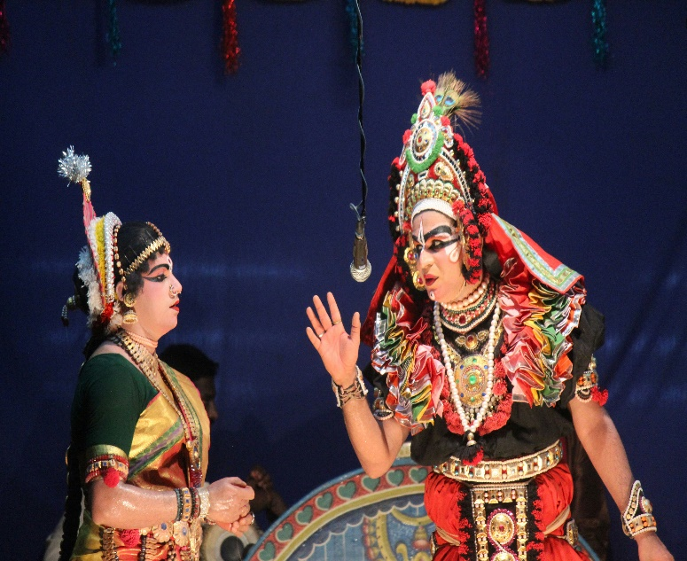**Introduction**

Bandi Chhor Divas, meaning "Day of Liberation," is a significant festival in Sikh history. It commemorates the release of the sixth Sikh Guru, Guru Hargobind Ji, along with 52 Hindu kings from the Gwalior Fort in 1619. Often coinciding with the Hindu festival of Diwali, Bandi Chhor Divas represents the Sikh values of freedom, justice, and compassion.

**Historical Background**

**Mughal Rule and Religious Persecution**

During the early 17th century, India was under the rule of the Mughal emperor Jahangir. Guru Hargobind Ji, known for his spiritual and martial leadership, was imprisoned in the Gwalior Fort under false political pretenses. While imprisoned, the Guru came into contact with 52 Hindu kings who were also unjustly detained by the Mughal regime.

**The Guru’s Release and a Condition of Freedom**

After significant lobbying by Sikh devotees and political negotiation, Jahangir agreed to release Guru Hargobind Ji. However, Guru Ji refused to leave unless the 52 kings were also freed. Jahangir tried to limit this by declaring that only those who could hold onto the Guru's cloak could leave with him. Guru Hargobind Ji had a special cloak made with 52 tassels, allowing each king to hold onto one and gain freedom.

**Significance and Modern Observance**

**Symbol of Liberation**

Bandi Chhor Divas is celebrated not only as a historical event but also as a symbol of standing up against injustice and fighting for the oppressed. It reflects Sikh ideals of courage, leadership, and selflessness.

**Celebrations Across the World**

On this day, Gurdwaras are illuminated with lights and candles, echoing the joy and light associated with liberation. Devotees engage in prayer, kirtan (spiritual hymns), and langar (community kitchen). The Golden Temple in Amritsar is particularly famous for its breathtaking decorations during Bandi Chhor Divas.

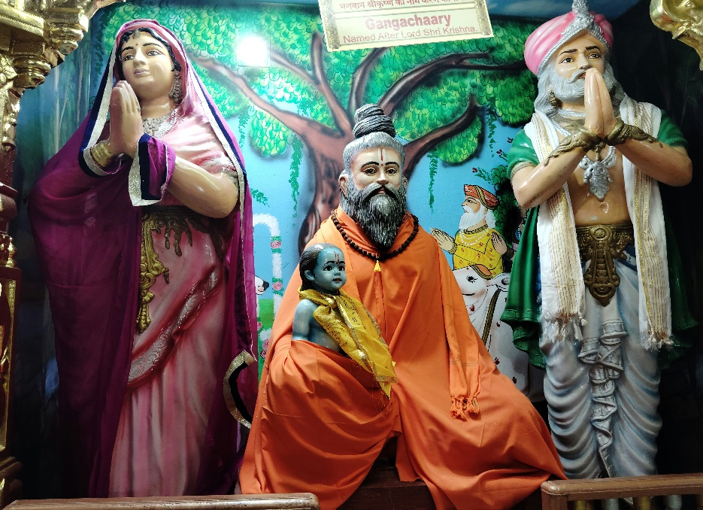**Comparison with Diwali**

Although Bandi Chhor Divas and Diwali often fall on the same day, they hold different religious meanings. While Diwali celebrates Lord Rama's return to Ayodhya, Bandi Chhor Divas focuses on Guru Hargobind Ji’s act of moral courage and the liberation of political prisoners.

**Conclusion**

Bandi Chhor Divas is more than a historical celebration—it is a reminder of the enduring values of freedom, justice, and the responsibility to protect others. Guru Hargobind Ji’s actions continue to inspire millions to stand against tyranny and support the downtrodden. The festival remains a powerful testament to Sikhism’s commitment to righteousness and service to humanity.

**References**

1. Singh, Khushwant. *A History of the Sikhs*, Volume 1. Oxford University Press, 2004.
2. Grewal, J.S. *The Sikhs of the Punjab*. Cambridge University Press, 1990.